**WEBSERVER(creation):**

so we need to write some Html code for our page if you are new to Html or not good at you can also visit this

* so we need to write some Html code for our page if you are new to Html or not good at you can also visit this

<https://www.w3schools.com/>

IFTTT:

**IFTTT:**

so I am using ifttt's webhook service to send me a notification on my phone for this you need to have ifttt app in your cell

* so I am using ifttt's webhook service to send me a notification on my phone for this you need to have ifttt app in your cell

firstly need an account in ifttt

* firstly need an account in ifttt

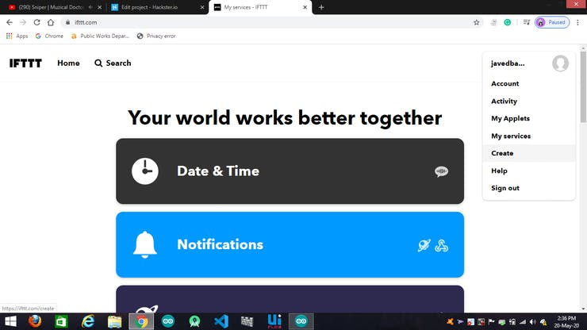

Click on create

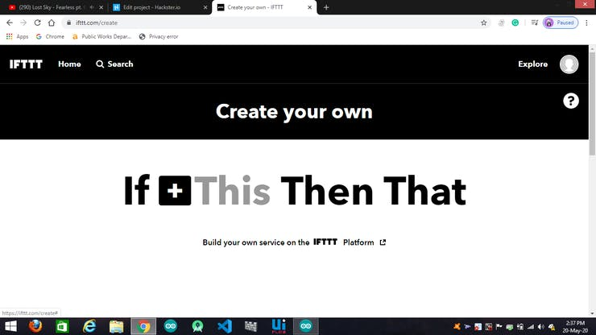

.click on THIS

* .click on THIS

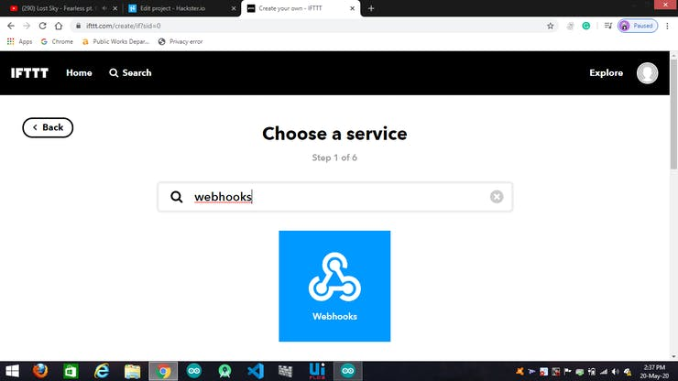

search webhooks and click on it

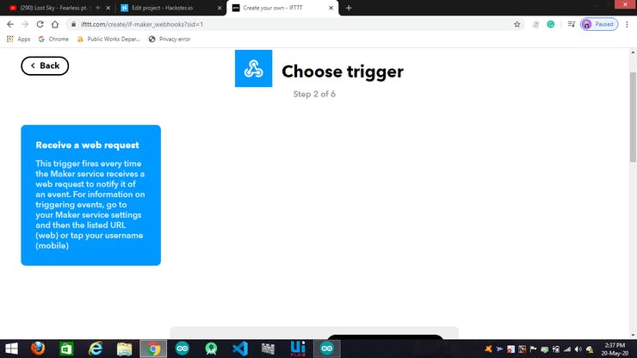

Click on Receive a web request

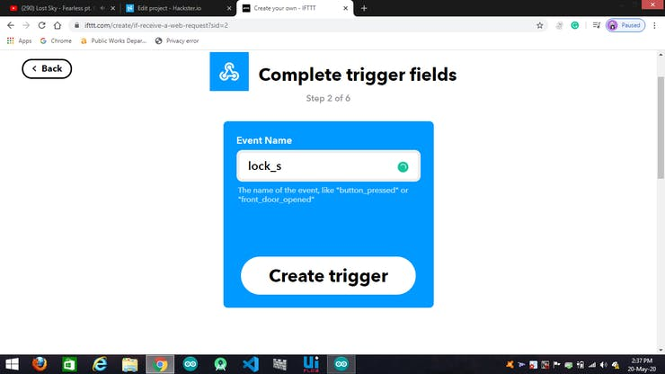

give event name as you want and also click on CREATE TRIGGER

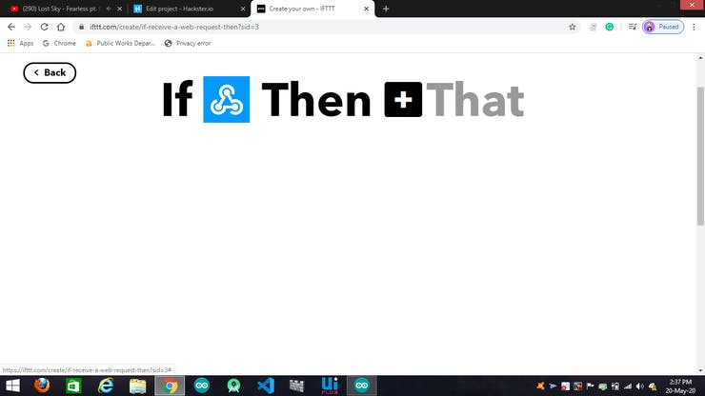

Click on THAT

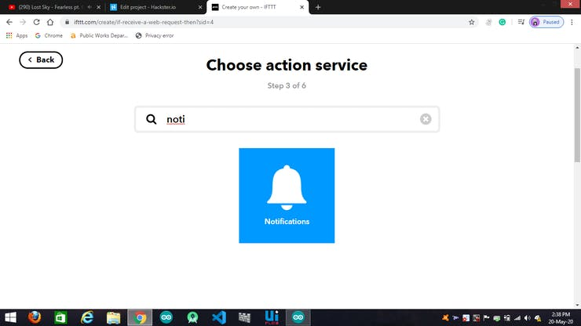

search notification and click on it

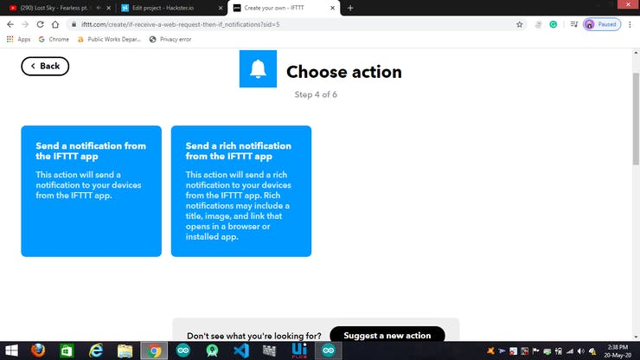

click on send a notification from the IFTTT app

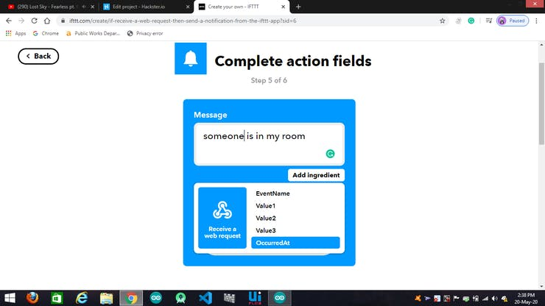

write your message and if want you can also add occurred at that means the time of occurrence

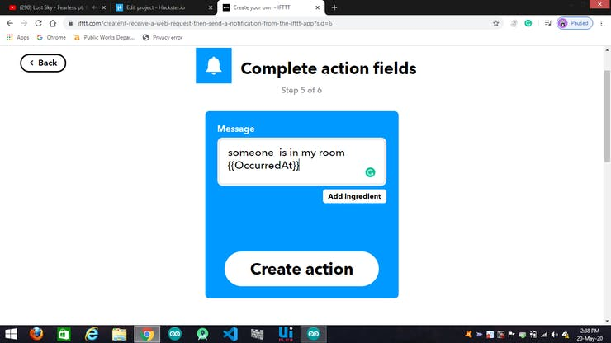

after this click on create action

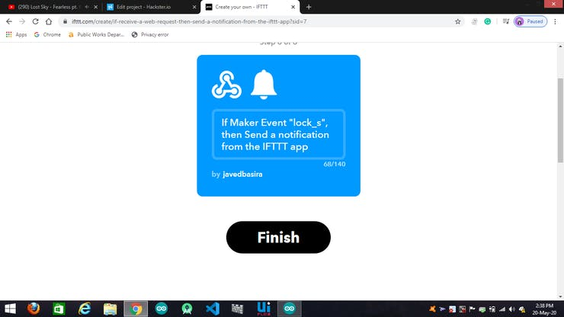

then click on finish

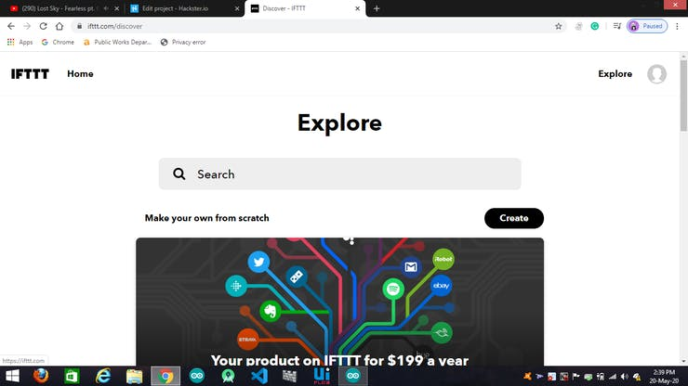

then click on home and go the home page

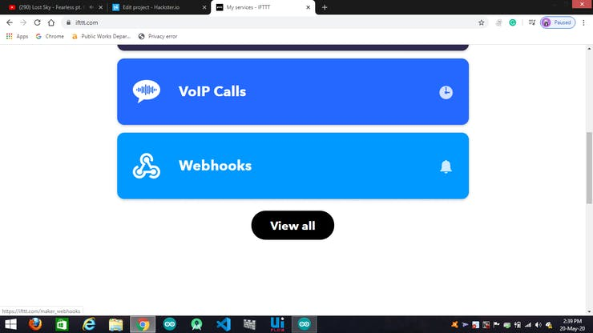

now click on the webhooks



now click on the documentation

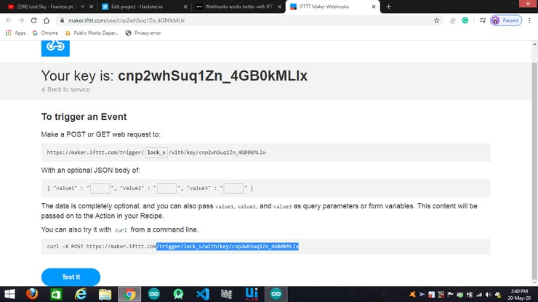

now type event in that box for ex: I write there lock_s my event name

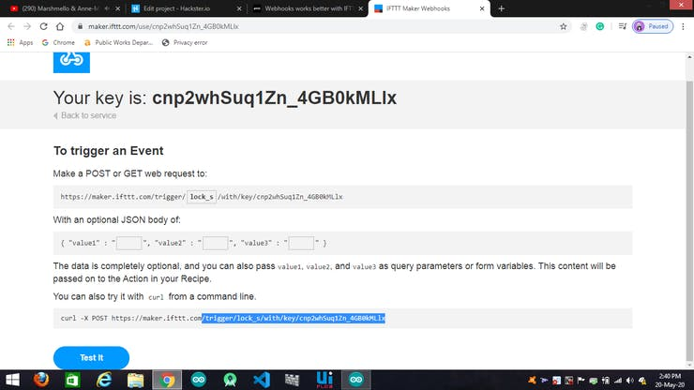

now copy the key and paste on your code and also by clicking on TEST IT you can test it and able to see the notification in your phone

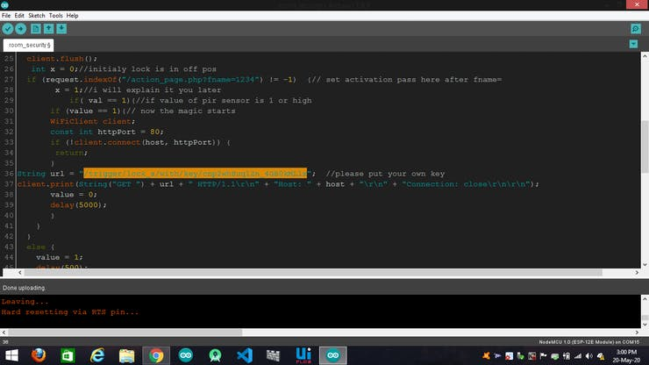

paste the key there.

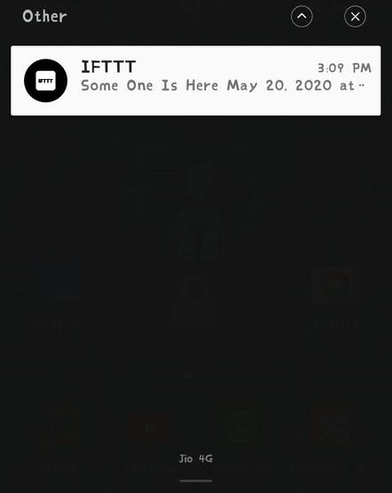

you will get this type of notification in your cell.

**Connection:**

* connect pir to D1 or GPIO 5 of NodeMCU
* connect the buzzer to D2 or GPIO 4 of NodeMCU

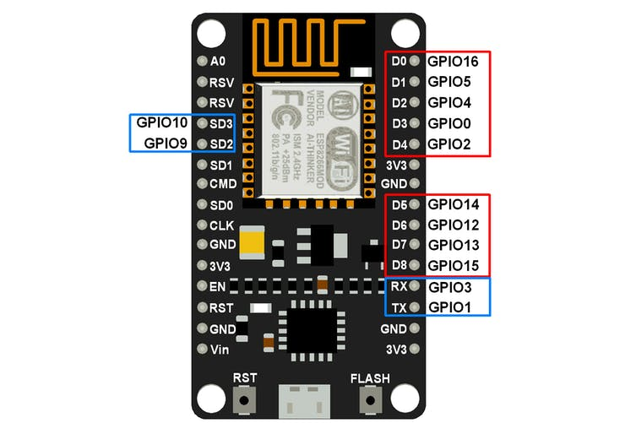

this will help you.

**WEBSERVER:**

* you need to put your board's IP on the browser to set and control the system.

in case you don't know the IP of your board

Serial.print(WiFi.localIP());

* you need to paste these lines on the setup of your code and don't forget to begin serial.
* so set a pass there to activities the system or deactivate the system.

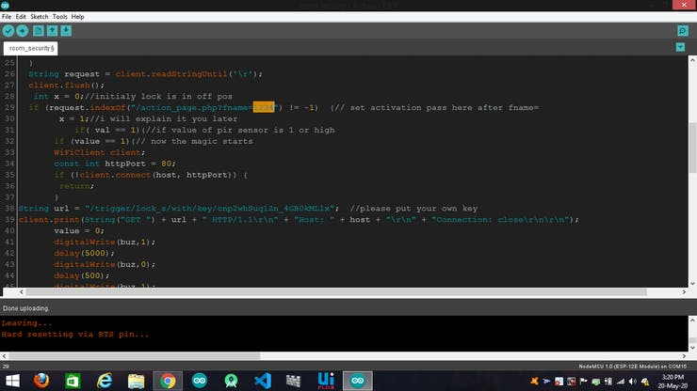

this is an activation pass you can also put as per your choice.

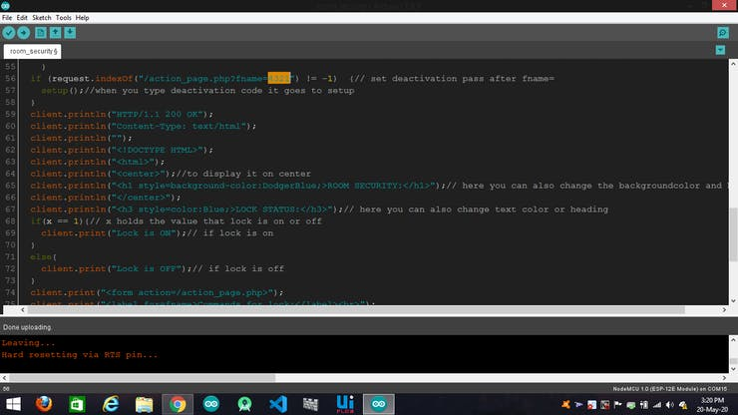

this is deactivation pass you can change as per your choice.

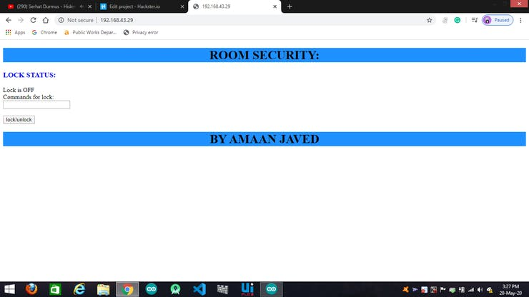

after giving pass click on the button to execute.